10.76: (a)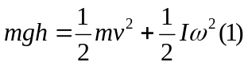
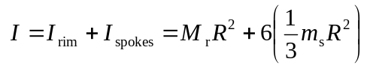
Uniform density means: 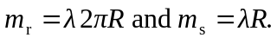 No slipping means that 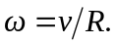 Also, substituting into (1) gives

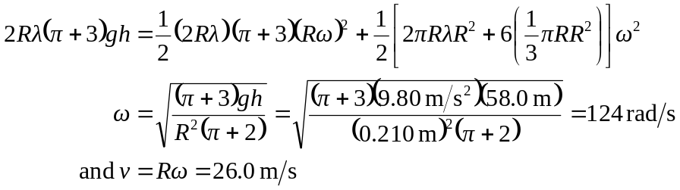

(b) Doubling the density would have no effect because it does not appear in the answer. 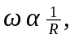 so doubling the diameter would double the radius which would reduce 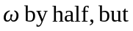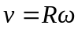would be unchanged.

